The book that I got for this class was “Sunday Enjoyments ; Religion made Pleasant to Children.,” It is a book from the year 1860 that was in the John Fontaine collection.
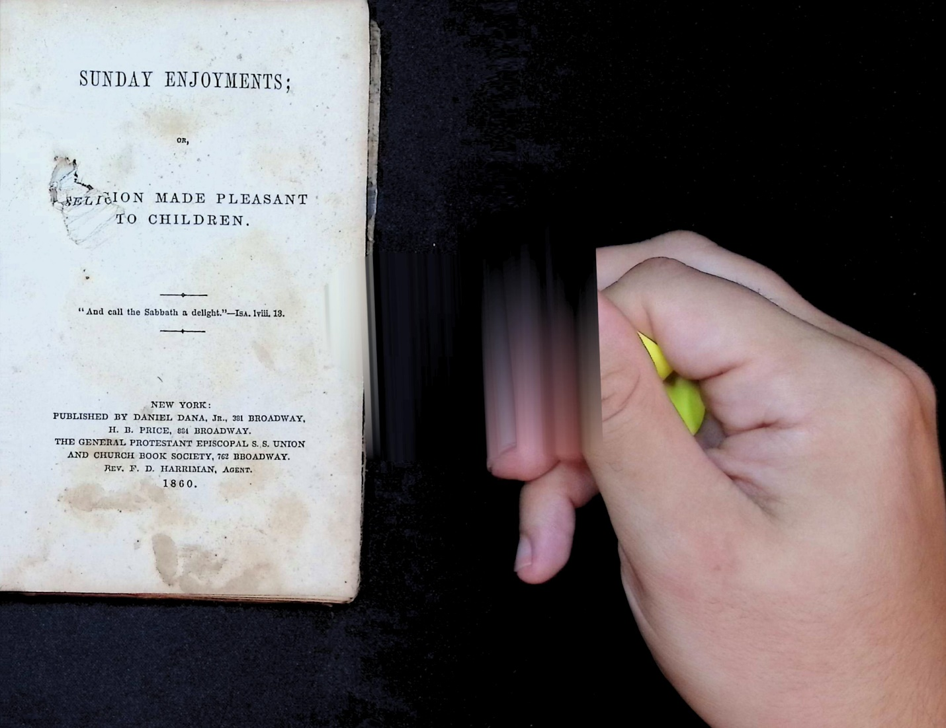
The book was a Sunday school book for children and something that I was very curious to look at was if Sunday school books today are the same as Sunday school books from that time I also wanted to know how we could use books as a time capsule.
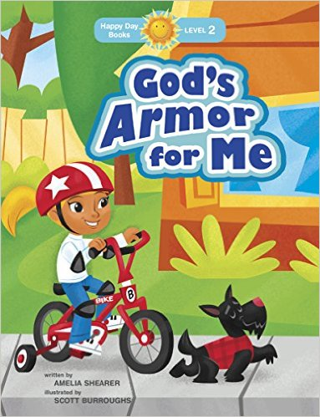
This image is an example of a modern day Sunday school book the first big factor that I noticed was that well obviously there is more color in the modern day books this is obvious because in 1860 they obviously could not print books with color. The biggest thing that I noticed is that in my book from the Fountaine collection is that it does not seem as dumbed down. Like to me the modern day Sunday school book seems as if it is more tooled towards a kids type book we would normally recognize.
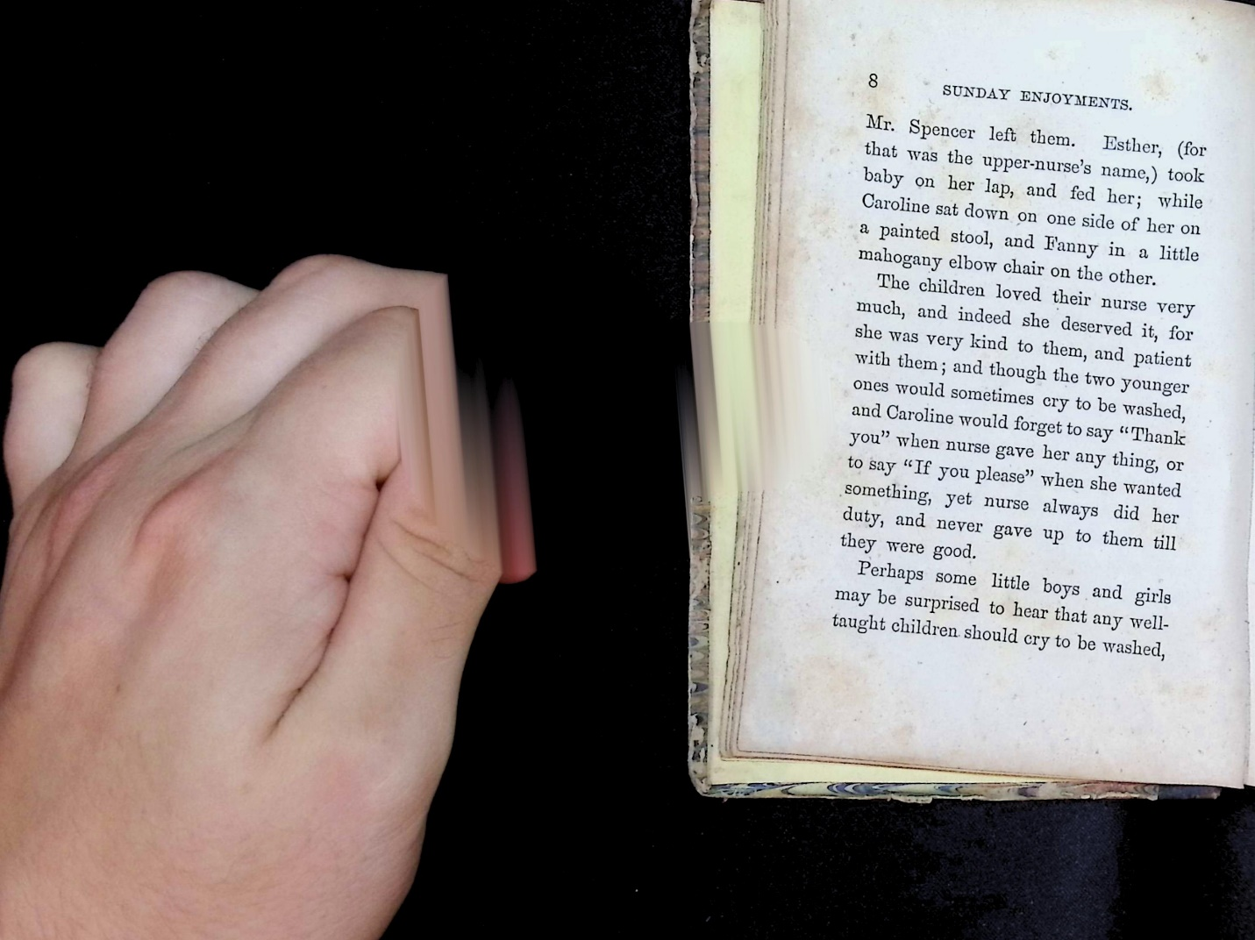
As an example here is a page from my book
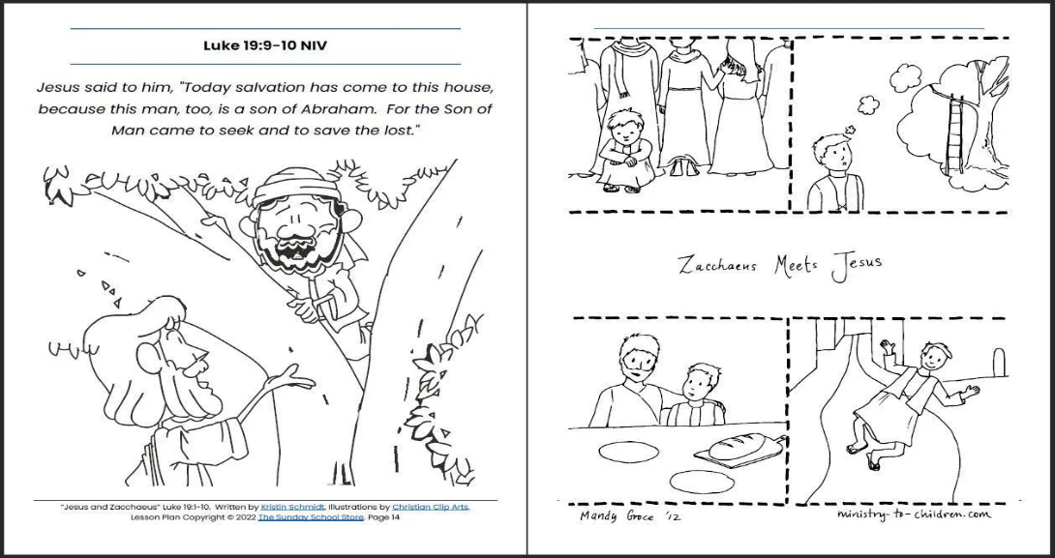
And here is a page form a modern Sunday school book for confirmation I talked to my grandmother about this and she has been teaching Sunday school in Pheonix City, Alabama since the 1980s and I asked her even in that shorter sample size if she had noticed that children’s Sunday school books were being dumbed down. And she actually said that she had noticed this over the years as well. They used to be similar to middle school aged kids books like the Diary of a Wimpy Kid. Now it seems that they are more similar to stuff like The Cat in the Hat more elementary books I asked her if she knew why that was and she said she was not really sure and I also asked her if she liked the direction that the books were headed in and she said that she really did not like the direction that the books were headed because she feels it could dilute some of the message that the Bible is trying to convey during that time then even just a few minutes ago I heard one of my classmates telling a story about her student teaching experience and she said that she felt as if that if she put a book in front of her kids she was not sure if they could read it. Now I do not know what age these kids were but I assume they were little kids and this makes me wonder if maybe this is not just a kids Sunday school problem but a bigger problem with children’s books in general. I wonder if by dumbing down these books we are hurting the kids reading comprehension. But my biggest take away from the class is how old books can be used as a time capsule from the time. One of my favorite things to do is to go back and watch old tv shows and look at the references from the time. If you go back and do this sometimes in like a sitcom you would have to go back and research and joke especially if it was about a famous figure from the time because that famous figure had fallen out of relevancy or died young or something like that. I think my obsession with this started when. I was a little kid because my mom used to love to watch reruns of the 1950s sitcom “I Love Lucy”
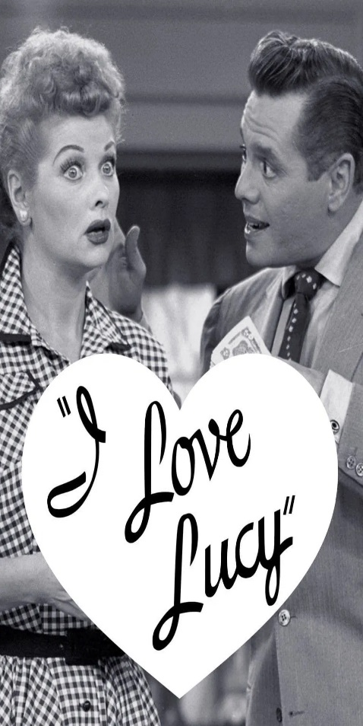
I think something like this is important for books too and it that was not really something I thought about until this class now my book because it was a Sunday school book luckily for me a lot of that stuff is still relevant in the church culture even though in the modern era it has seemed that we have dumbed down the children’s books. But I heard my classmate tell a really cool story about his book and how he could not find sources for his book because they got burned during the Civil War. This shows as a real capsule of the time and I now can associate that feeling when I look at older books like I do with older tv shows. So in conclusion from my project I learned that it seems that not only are kids books in Sunday school are being dumbed down it seems like that children’s books as a whole are being dumbed down and I also learned that books can be used a time capsule just like a old tv show.

Sources

Hoy, Angela. “OUR READERS HAVE SPOKEN: Dumbing Down Children’s Books Is a VERY BAD IDEA!!” WritersWeekly.com, 9 Oct. 2020, writersweekly.com/angela-desk/our-readers-have-spoken-dumbing-down-childrens-books-is-a-very-bad-idea. Accessed 18 Nov. 2025.
WritersWeekly.com

I Love Lucy (TV Series 1951–1957) – Posters. The Movie Database, www.themoviedb.org/tv/2730-i-love-lucy/images/posters?language=en-US
. Accessed 18 Nov. 2025.
The Movie Database

“Top 100 Best-Selling Sunday School Books for Ministry.” Sharefaith Magazine, Sharefaith, Mar. 2016, www.sharefaith.com/blog/2016/03/top-100-best-selling-sunday-school-books-ministry
. Accessed 18 Nov. 2025.
sharefaith.com

“Jesus and Zacchaeus (Luke 19:1-10) Printable Bible Lesson & Sunday School Store.” SundaySchool.Store, Sunday School Store, www.sundayschool.store/products/jesus-and-zacchaeus-lesson
. Accessed 18 Nov. 2025.

